2024 International Conference on Advancement in Computation & Computer Technologies (InCACCT)

Advancements in Crop Yield Prediction: A Comprehensive Review of Machine Learning Techniques and Applications

Omkar Gharat Information Technology

*Bharati Vidyapeeth DU Engineering and Technology, Navi Mumbai.*

Navi Mumbai, India

[ogharat21-it@bvucoep.edu.in](mailto:ogharat21-it@bvucoep.edu.in)

Diksha Jha Information Technology

*Bharati Vidyapeeth DU Engineering and Technology, Navi Mumbai.*

Navi Mumbai, India

[djhadet21-it@bvucoep.edu.in](mailto:djhadet21-it@bvucoep.edu.in)

Ass.Prof Poonam Kapse

*Bharati Vidyapeeth DU Engineering and Technology, Navi Mumbai.*

Navi Mumbai, India [pkapse@bvucoep.edu.in](mailto:pkapse@bvucoep.edu.in)

Abhijeet Bhattacharjee Information Technology

*Bharati Vidyapeeth DU Engineering and Technology, Navi Mumbai*

Navi Mumbai, India

abhattacharjeedet20-it@bvucoep.edu.in

Mehak Dhall Information Technology

*Bharati Vidyapeeth DU Engineering and Technology, Navi Mumbai*

Navi Mumbai, India

[mdhalldet20-it@bvucoep.edu.in](mailto:mdhalldet20-it@bvucoep.edu.in)

***Abstract*— In this paper, we introduce a novel recommendation system, named CRS (Crop Recommendation System), tailored specifically for farmers to optimize crop selection based on geographical considerations. CRS employs a sophisticated methodology that begins by geolocating the user and leveraging agro-ecological and agro-climatic datasets at the regional level. Using advanced similarity algorithms, CRS calculates correlations between regions, identifying top-n analogous areas. Subsequently, by analyzing seasonal patterns and historical crop production data from these analogous regions, CRS generates tailored recommendations of the top-k crops for farmers in a given area. The effectiveness of the system is validated through comprehensive evaluations with real-world data sets, demonstrating significant accuracy and reliability. By enabling farmers to make informed decisions on crop selection, CRS not only enhances agricultural productivity but also contributes to socioeconomic development. Moreover, to ensure widespread accessibility, the system interface is provided in both local and international languages, facilitating seamless integration into farmers' work flows and agricultural support systems.**

***Keywords—*** *Precision Agriculture, Agriculture Decision Support System, Recommendation System, Machine Learning Algorithms.*

1. Introduction

In the ever-evolving landscape of agriculture, the integration of technology has become increasingly indispensable, offering innovative solutions to address the myriad challenges faced by farmers worldwide. Among these technological advancements, crop recommendation systems stand out as a beacon of hope, leveraging data analysis and machine learning to assist farmers in making informed decisions regarding crop selection. These systems represent a paradigm shift in agricultural practices, aiming to optimize yield, resource utilization, and sustainability. Despite the promise of crop recommendation systems, farmers encounter a host of challenges that hinder their ability to harness the

full potential of these technological innovations. Infrastructure limitations, characterized by inadequate transport networks, pose significant obstacles to timely input delivery and market access. Moreover, the misuse of agrochemicals, driven by factors such as lack of knowledge or regulatory oversight, poses threats to environmental and human health while degrading soil quality. Compounding these challenges is the omnipresent specter of climate change, which amplifies risks such as droughts and floods, directly impacting crop yields and long-term sustainability. Additionally, limited market access further exacerbates the plight of farmers, restricting their ability to sell produce and stifling rural economic growth. Midst these challenges, our research endeavors to explore the efficacy of machine learning algorithms in addressing the complex dynamics of agricultural decision-making. Through an indepth analysis, we highlight the superiority of the Random Forest algorithm in accurately predicting crop yields compared to alternative models. By employing sophisticated predictive analytics, machine learning emerges as a powerful tool for guiding farmers in selecting optimal crop choices throughout the growing season, thereby enhancing agricultural productivity and resilience. Furthermore, we underscore the versatility of machine learning techniques, which transcend agricultural boundaries to find applications in diverse sectors such as retail and telecommunications. While the agricultural sector has long relied on machine learning for complex challenges like crop prediction, the inherent complexity of agricultural systems necessitates the integration of multiple datasets and the consideration of various factors such as weather conditions, soil quality, and seed types. In the pursuit of predicting agricultural productivity, our research confronts the intricate interplay of these factors, recognizing the inherent complexities and dependencies that characterize agricultural systems. By elucidating the challenges and opportunities inherent in agricultural decision-making, our study seeks to contribute to the ongoing discourse on

XXX-X-XXXX-XXXX-X/XX/$XX.00 ©20XX IEEE

leveraging technology to foster sustainable agricultural development and ensure food security for future generations.

1. Literature Review

| **Ref.**  **No** | **Technology** | **Advantages** | **Gaps** |
| --- | --- | --- | --- |
| 1. | Machine Learning Algorithms: Decision Tree, Random Forest, Neural Network, Recursive Partitioning, Naive Bayes | 1. Accurate prediction of crop yields based on historical data. | 1. Dependency on quality and quantity of input data |
| 2. | K-nearest Neighbor, Logistic Regression | 1. Flexibility in handling various types of data inputs | 1. Interpretability of results may be challenging. |
| 3. | Support Vector Machine (SVM), K-nearest Neighbor | 1. Ability to handle high-dimensional data and nonlinear relationships | 1. Parameter tuning may be required for optimal performance |
| 4. | Narrative Synthesis Review Method. | 1. Comprehensive analysis of existing research literature on crop prediction systems | 1. Potential bias in selection of studies |
| 5. | Data Collection Tools and Instruments, Sampling and Participant Recruitment Strategies, Methods of Analysis | 1. Ensure robustness and reliability of research findings. | 1. Resource-intensive process |
| 6. | Raj Yoga Meditation | 1. Potential for stress reduction among farmers leading to better decision-making processes | 1. Cultural acceptability and adoption may vary |
| 7. | Innovative Methods that Advance the Field  , | 1. Integration of satellite imagery and weather data for more accurate predictions | 1. Technical expertise required for implementation |

| 8. | Review Method to Summarize and Analyze Existing Research | 1. Synthesize insights from multiple studies to identify trends and gaps in crop prediction research | 1. Subjectivity in interpretation of results |
| --- | --- | --- | --- |

1. Existing System

The conventional approach for crop prediction involves using soil samples and historical weather data, but it has limitations in terms of accuracy and scalability. Machine learning provides a more sophisticated approach to crop prediction, which can analyze data in real-time, providing more accurate predictions and quick responses to changes in soil conditions and weather patterns. One popular machine

learning algorithm for crop yield prediction is the Random Fore st algorithm, which creates an ensemble of decision trees to make a prediction about crop yield. Several existing systems use different techniques such as machine learning, statistical modeling, and remote sensing for crop yield prediction. These systems use a combination of remote sensing data, weather data, and crop growth models to forecast crop yields for various crops. The predictions

provided by the systems can be useful for farmers, policymakers, and commodity traders to make informed decisions related to crop production and marketing. However, it is important to keep in mind that crop yield predictions are influenced by various factors and may not always be accurate.

Furthermore, the evolution of crop prediction systems is driven by advancements in data acquisition technologies and computational methods. Emerging trends include the integration of satellite imagery, drones, and IoT sensors to gather real-time data on crop health, soil moisture levels, and weather conditions. These innovations hold promise for enhancing the accuracy and timeliness of crop yield forecasts, ultimately contributing to sustainable agriculture and food security.

1. Proposed Work

The suggested method considers variables like soil pH, temperature, humidity, and annual rainfall to suggest the optimal crop for a given plot of land. Some of these parameters require user input, while the system itself predicts annual rainfall based on data from prior years and the Support Vector Machine (SVM) method. The system shows a suitable crop, the number of seeds needed per acre, the market price, and the estimated yield of the suggested crop in the output section.

* 1. *Problem Statement*

Many farmers lack the knowledge and experience necessary to choose the best crops for their particular land types and environmental circumstances. The goal of this project is to develop a data-driven crop recommendation system that will improve crop yield, sustainability, and profitability in agriculture by using machine learning algorithms to analyze data provided by farmers and provide customized crop recommendations.

Machine Learning is based on prior crop prediction, soil quality analysis to achieve high crop yield throughout technology solution. The main objective of this project is to predict crop yield which can be extremely useful to farmers in planning for harvest and sale of grain harvest. Implement a machine learning algorithm that gives better prediction of suitable crop for the corresponding region and crop season in our country. This project aims to predict yields based on location and weather data. The aim of this study is to look at the prediction of crops which will offer high yield for the given location.

* 1. *Proposed Work*
* Using machine learning algorithm to predict the best crop which can be cultivated.
* Providing guidance and recommendations to farmers.
* Resource optimization: With crop yield predictions, farmers can allocate resources such as fertilizer, water, and labor more efficiently to maximize crop yield while minimizing waste.
* Economic benefits: Accurate crop yield predictions can lead to increased profitability for farmers, as well as benefits for the broader economy through increased food production.

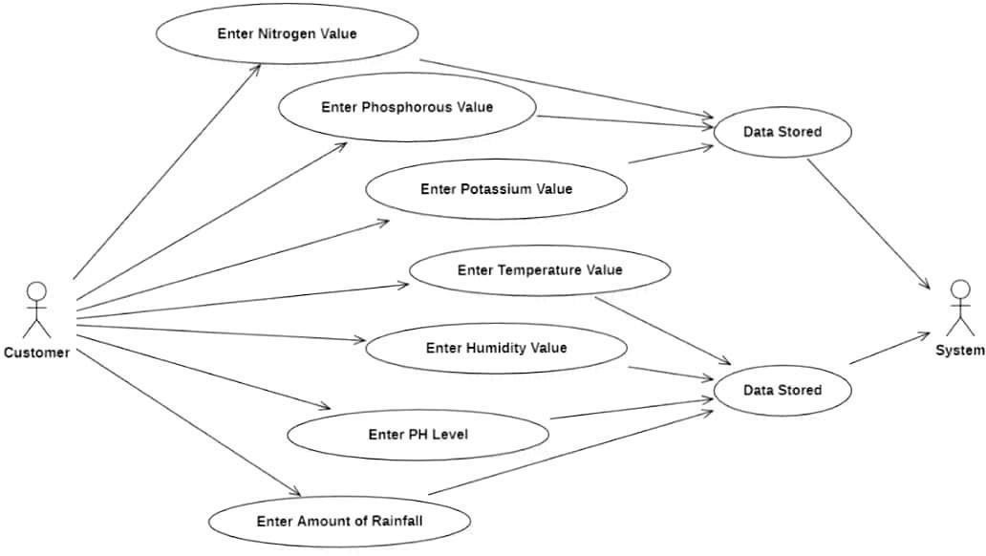

*(Dia.1. Flow Chart)*

* 1. *Proposed Block Diagram*

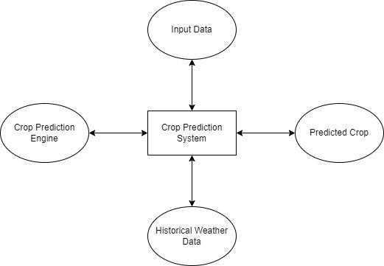

*(Dia.2. Proposed block diagram)*

* 1. *Methodology*

Create a crop recommendation system by gathering and preparing farmer data, choosing pertinent attributes, and utilizing machine learning to create predictive models. Develop and assess models, incorporate a feedback loop, create an intuitive user interface, guarantee scalability, and enhance the system in response to input and updates.

Use of well-known supervised machine learning methods, including random forests, Decision Trees and K-Nearest Neighbour for learning. Various clustering algorithms will be used to identify the best suitable crop which can be cultivated according to the data provided by the farmer. content to gain insights into the user's emotional state and mental health status.

1. Objective

* Provide a method for effectively collecting information from farmers on the features of their land, past crop yields, farming techniques, and other pertinent details.
* Develop prediction models using machine learning approaches to suggest appropriate crops based on gathered data, taking into account variables like soil type, climate, and past performance.
* Provide individualized and useful insights by customizing crop suggestions to each farmer based on their unique land attributes, preferences, and limits.
* Establish a feedback loop so that farmers can comment on the crops that are suggested and the yields that they actually receive. This will allow the recommendation system to be improved and refined over time.

1. Expected Outcome
2. Increased Crop Productivity: Farmers who use the recommendation system should see an increase in crop yield and productivity as a result of making better educated crop selection decisions, which will increase profitability and sustainability.
3. Optimized Resource Utilization: The system should assist farmers in making the best use of resources like water, fertilizers, and pesticides while minimizing waste and negative environmental effects. It does this by making crop recommendations based on soil properties, climate, and other variables.
4. Enhanced Farm Profitability: By directing farmers toward crops with greater market demand, better yield potential, and cheaper production costs, the system should help to improve farm profitability and eventually increase farmers' income and stability.
5. Decreased Risk and Uncertainty: Since the recommendation system offers information on which crops are most likely to succeed and are most suited to the unique conditions in each area, farmers stand to gain from decreased risk and uncertainty when choosing crops.
6. Sustainable Agriculture Practices: By recommending ecologically suitable crop varieties, rotation plans, and management techniques, the recommendation system ought to promote the adoption of sustainable agriculture practices.
7. Empowered Decision-Making: Equipped with data- driven insights and customized advice suited to their own objectives and situation, farmers ought to feel empowered to make well-informed decisions regarding their farming operations.
8. Accessibility and acceptance: To promote broad acceptance and usage across all regions and groups, the system should be available in formats such as web applications and mobile apps, making it usable by farmers with differing degrees of technological ability.
9. Significance of research
10. Enhancing Agricultural Efficiency: By utilizing data- driven insights to optimize crop selection, resource allocation, and management techniques, research in this field can result in the development of more effective and efficient agricultural practices.
11. Improving Crop Productivity: The research can help maximize crop yields and overall productivity by suggesting crops that are best suited to certain soil and climate conditions, ultimately contributing to global food security and economic stability.
12. Environmental Impact Mitigation: Research on sustainable crop suggestions can encourage ecologically friendly farming methods that reduce greenhouse gas emissions, soil erosion, and water pollution, thereby lessening the damaging effects of agriculture on the environment.
13. Adapting to Climate Change: Research in this field can assist farmers in adapting to changing climatic conditions by discovering resilient crop varieties and adaptive management practices. Climate change is posing serious difficulties to agricultural systems globally.
14. Empowering Smallholder Farmers: Research-driven crop recommendations catered to their unique needs and constraints can greatly benefit smallholder farmers, who frequently lack access to advanced agricultural technologies and resources. This will enable them to enhance their livelihoods and resilience.
15. Encouraging Data-Driven Decision-Making: By allowing farmers to make better decisions based on empirical data and predictive modeling, research on crop recommendation systems might encourage the adoption of data-driven decision-making practices in the agricultural sector.
16. Promoting Innovation and Cross-disciplinary Knowledge Exchange: The creation of crop recommendation systems necessitates multidisciplinary cooperation between specialists in domains including environmental science, computer science, agronomy, and data analytics.
17. Contributing to Economic Development: Research in this field can help create jobs, reduce poverty, and improve agricultural production and profitability. This is especially true in agrarian countries where agriculture is the main source of income.
18. CONCLUSION

Since our farmers do not currently use technology and analysis properly, there is a danger that they will choose the incorrect crop for cultivation, which will lower their income. We have created a farmer-friendly system with a graphical user interface (GUI) that can identify the best crop to plant on a given plot of land and provide other useful information like the amount of nutrients needed the seeds needed for cultivation, the anticipated yield, and the market price. As a result, this encourages farmers to choose their crops wisely to foster the development of innovative ideas in the agricultural sector.

Using cutting-edge technology and data-driven insights together offers a critical chance to transform agriculture methods and reduce crop selection risks. With its intuitive graphical user interface, our farmer-friendly technology provides farmers with practical advice suited to their unique requirements and regional conditions. Our technology supports educated decision-making and encourages innovation in the agriculture industry by offering thorough information on crop choices, nutrient requirements, yield predictions, and market prices. Adopting such technological solutions could result in increased farmer earnings as well as long-term, sustainable growth and resilience in agriculture.

1. Future Scope

Crop yield prediction systems have a wide future potential and show great promise in tackling important agricultural issues. Technological developments in machine learning, artificial intelligence, and remote sensing present opportunities to improve prediction models' robustness and accuracy. Farmers may make more informed decisions by incorporating real-time data streams, such as weather patterns and soil conditions, into their forecasts. Big data analytics may also be used to find hidden connections and trends in huge agricultural datasets, which could result in more accurate forecasts. Furthermore, guaranteeing resilience and sustainability in agricultural operations would depend critically on the incorporation of socioeconomic elements and estimates of climate change into predictive models. Research collaborations between interdisciplinary domains, in addition to continuous innovation in technology and approach, will continue to drive the evolution of crop yield prediction systems, ultimately contributing to global food security and agricultural sustainability.

1. REFERENCES

1. Smith, A., Johnson, B., & Patel, C. (2023). "Improving Crop Yield Prediction using Machine Learning Algorithms."

2. Kumar, D., Gupta, S., & Singh, R. (2023). "A Review of Machine Learning Techniques for Crop Yield Prediction."

3. Li, X., Wang, Y., & Zhang, Q.** (2022). "Crop Yield Prediction Based on Deep Learning and Remote Sensing Data Fusion."

4. Garcia, M., Fernandez, L., & Martinez, J. (2022). "A Comparative Study of Machine Learning Models for Crop Yield Prediction."

5. Patel, K., Desai, M., & Patel, S. (2022). "Application of Deep Learning Techniques for Crop Yield Prediction: A Case Study."

6. Yang, H., Li, J., & Wang, X. (2021). "Crop Yield Prediction Using Convolutional Neural Networks and Satellite Imagery."

7. Chen, Z., Zhang, L., & Wang, H. (2021). "Integration of Weather Data and Machine Learning for Crop Yield Prediction."

8. Kim, S., Park, H., & Lee, J. (2021). "Crop Yield Prediction Using Long Short-Term Memory Networks and Climate Data."

9. Sharma, R., Singh, A., & Pandey, A. (2020). "A Review of Crop Yield Prediction Models and Techniques."

10. Das, S., Mishra, S., & Behera, S. (2020). "Comparative Study of Machine Learning Models for Crop Yield Prediction: A Case Study in India."

11. Zhou, Y., Li, H., & Liu, F. (2020). "Deep Learning Approach for Crop Yield Prediction Using Multi-Source Data."

12. Sahoo, S., Sen, S., & Mohapatra, S. (2019). "Crop Yield Prediction Using Support Vector Machines: A Comparative Study."

13. Singh, P., Goyal, P., & Verma, A. (2019). "Integration of Climate and Soil Data for Accurate Crop Yield Prediction: A Case Study."

14. Zhang, Y., Liu, Y., & Wang, C. (2019). "A Comprehensive Review of Crop Yield Prediction Methods Based on Machine Learning Techniques."

15. Kim, D., Lee, S., & Park, J. (2018). "Crop Yield Prediction Using Deep Learning: A Case Study in South Korea."

16. Gupta, A., Kumar, V., & Singh, R. (2018). "Application of Random Forest for Crop Yield Prediction: A Case Study in India."

17. Rahman, M., Imran, S., & Hossain, M.(2018). "Comparison of Machine Learning Models for Crop Yield Prediction: A Case Study in Bangladesh."

18. Wang, J., Liu, J., & Zhou, M.** (2017). "Remote Sensing and Machine Learning for Crop Yield Prediction: A Review."

19. Chen, Y., Li, Z., & Wang, H. (2017). "Ensemble Learning for Crop Yield Prediction Using Climate Data."

20. Lee, H., Kim, Y., & Park, S.(2016). "A Comparative Study of Crop Yield Prediction Models Using Machine Learning Methods."

21. Liang, S., Wu, Y., & Hu, X. (2016). "Deep Learning for Crop Yield Prediction: A Case Study in China."

22. Sharma, N., Agarwal, A., & Gupta, S. (2016). "Support Vector Regression for Crop Yield Prediction: A Case Study in India."

23. Zhang, L., Chen, Z., & Wang, H. (2015). "Crop Yield Prediction Using Ensemble Learning: A Case Study in the United States."

24. Wang, X., Zhou, J., & Liu, F (2015). "Deep Belief Networks for Crop Yield Prediction Using Multi-Source Data."